Wide-Frequency Linear Haptics

Step 1: copy the audio file of the Wide-Frequency Linear Haptics to the specified directory.

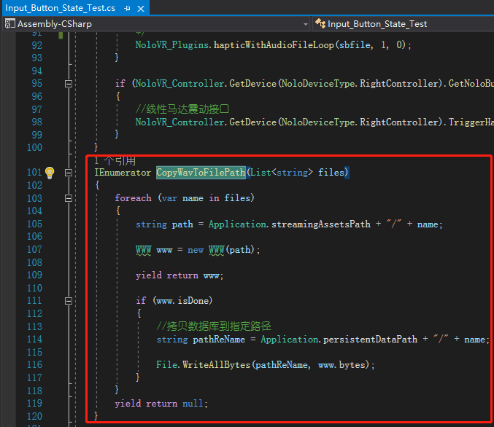

Step 2: Run the copy function when the game is started.
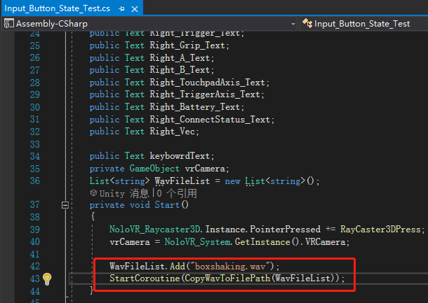

Step 3: Use the Wide-Frequency Linear Haptics interface HapticWithAudioFileLoop, the timing of calling this interface can be based on the scenario of the game, and the interface parameters are based on your requirements. This screenshot is a sample of calling the interface.

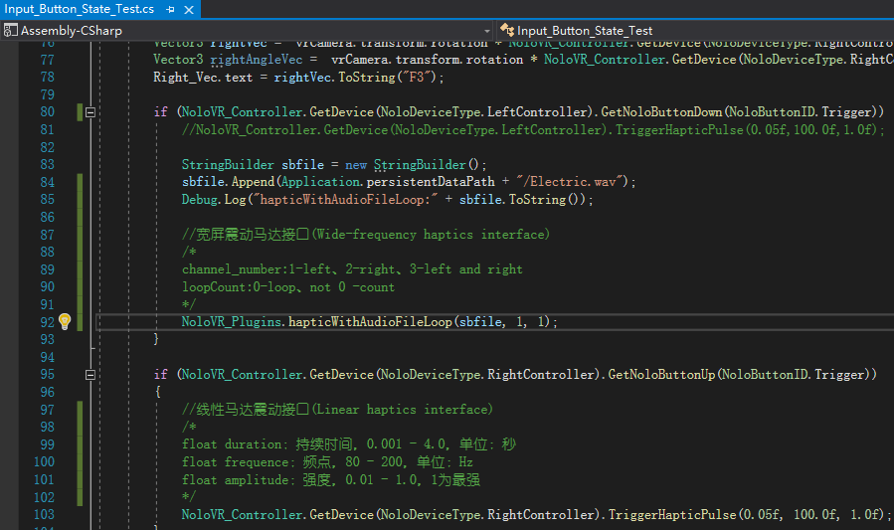

For more details, please check Canvas/ShowButtonStates/Input_Button_State_Test in the QuickStartScene scene.

